Introduction

Ambrose Inc. is a company that specialise in Electronical Sales.

Sample text to indicate font style, font size and line spacing required for this project. Please complete all areas of this template with comprehensive and concise details about design and evaluation.

Overview of Company details and aims
The aims of the spreadsheet are;

To calculate the wages of 12 employees.
Use an IF function to calculate the hourly rate.
Calculate basic pay by multiplying hours by hourly rate.
Calculate commission based on sales by using a lookup or if function
Deduct tax from gross pay.

List of Specific Problems
Calculating tax
Deducting tax from the gross pay
Using lookup to calculate commission based on sales

List of Solutions

Input and Output Data Identified

Input data

Output data

Data Processing
Layout of spread sheet detailing all aspects of the design
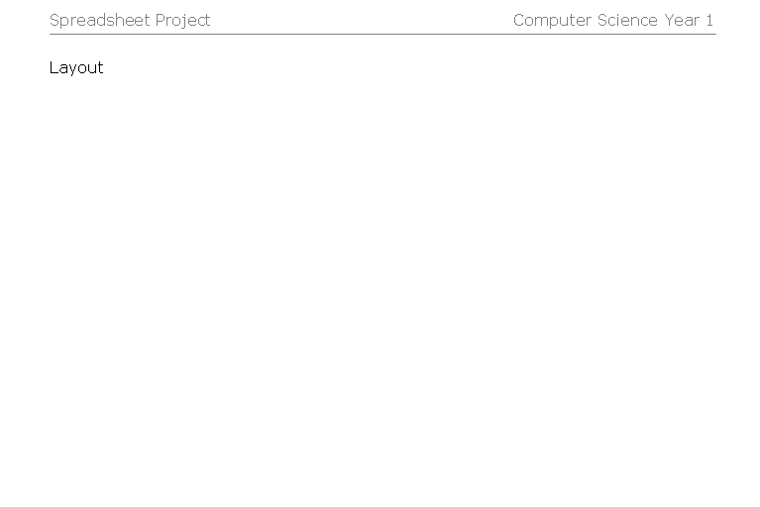

Header

Font = ?

Layout was decided because ?

Footer
Production and Implementation
(printouts of your spreadsheet)

Two sets of printouts must be used one is the original and the other shows what happens when a value is changed. Please do not forget to do this.
Evaluation

Explain things that were successful and difficulties that you overcame (details) .
Modifications to improve the spreadsheet

